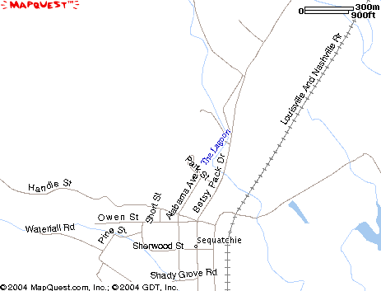
Coppinger Cove Rd
Old Hwy 28
Betsy Pack Dr.
Coppinger Cove Baptist Church

